

**Division of Engineering Programs**

**EGM302-01 Finite Element Analysis**

**Fall 2017**

**Senior Design – ANSYS - Project**

Stephanie Fernandez

**Problem Statement**

For senior design, an IoT (Internet of Things) sliding pet door is being designed. The main focus for this FEA project is on the sliding door. A set of a rack and pinion gear will be on each side of the door, with the pinion gears being rotated by motors, in order to lift and lower the door. The instance of the pinion gear interacting with one tooth on each side will be analyzed in ANSYS in order to understand if the teeth on the rack gear will not break due to the weight of the door.

**Model Setup**

*Geometry Creation/Import*

The model was made in SolidWorks, saved as a parasolid file, and the imported into ANSYS. In SolidWorks, a rectangular door with rack gear teeth on the left and right sides was made. In reality, there will be a door made of plastic and wooden rack gears epoxied onto the two sides of the door. But, for simplification, in ANSYS, the entire door material was made to be oak wood. The Young’s Modulus [1], Poisson’s Ratio [2], and density [3] were researched and inputted into ANSYS Engineering Data for a new created material, oak. Below is the SolidWorks and ANSYS models image in Figure 1.

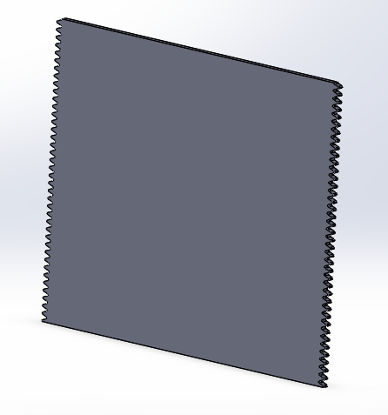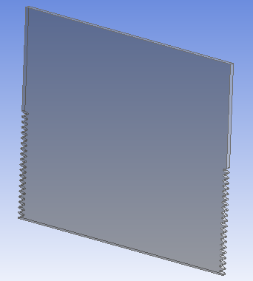

Figure 1: SolidWorks model (left) vs ANSYS model (right).

The ANSYS model looks different because it was made to have less teeth than the original model. This was because when the original model was imported into ANSYS, it exceeded the geometry limit for the student version of ANSYS. ANSYS Academic allows for a maximum of 300 faces in a geometry, so putting less teeth satisfied this in the end. This simplification was okay because the instance of the rack and pinion gear interacting was going to be at the bottom most rack gear tooth. This was decided also to have the whole door being held up, which would be the worst case scenario.

*Meshing Strategy*

In ANSYS, Static Structural was chosen for the project because this was going to be a structural analysis on a static model. Once the engineering data was set up and the geometry was imported, the next step was the mesh. First, a sizing mesh control was done on the front and back faces with default element size to get a basic, automatic mesh. Then, face meshing was done on the model in order to smooth out some lines, like the video from the heat conduction in EdX taught. Next, two edge sizing’s were done. One on the long edge going across the front with a number of elements of 10 and the second edge sizing was done on the short side edges of each side with a number of elements of 4. The long edge sizing was made to have only 10 elements because along the front was not the most important part of the analysis; it was the teeth on the sides. As for the side edge sizing, originally, it had only one element, which would not show much distribution along a tooth face, and this was the most important section of the model. Therefore, it was made into 4 elements. It could have been more to be even more accurate, but the number of nodes on ANSYS Academic cannot exceed 32,000 nodes, and the final count for this project was 28,097 nodes. The mesh is shown below in Figure 2.

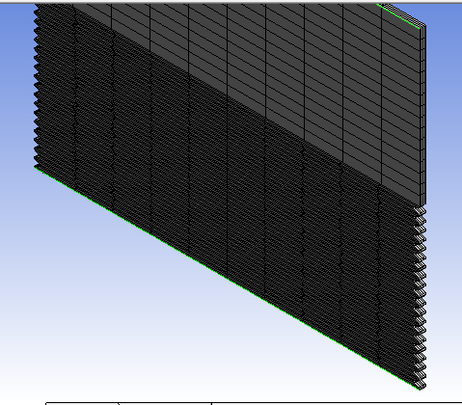 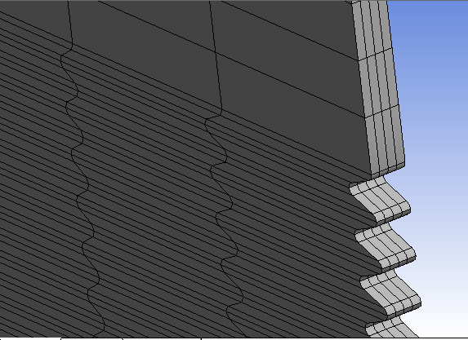

Figure 2: Mesh on ANSYS Mechanical (and zoomed in).

*Boundary Conditions*

In this project, there were two boundary conditions added in ANSYS. The first was an inertial Standard Earth Gravity on the body in the downward direction. The second boundary condition was putting fixed supports at the bottom most tooth on both sides. The fixed support represented the rack gear being held up by the pinion gear. At this point, there should be no movement, which is why it is a fixed support.

*Solution Strategy*

Once the mesh was done and below the ANSYS Student limit and the boundary conditions were put on the model, the solution was solved. For this project, the two worries were the stress and deformation of the teeth on the door (and the door itself). Therefore, a normal stress and total deformation was solved for in ANSYS and then analyzed.

**Results**

*Total Deformation*

Once ANSYS solved for the total deformation, the result was shown (Figure 3 below).

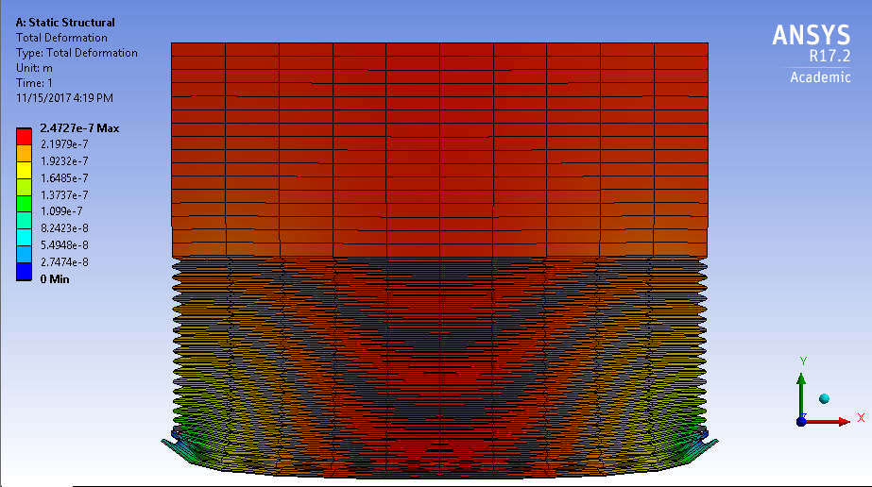

Figure 3: Auto-scaled deformation ANSYS result.

This was the auto-scaled result of the deformation and auto-scale makes the model have an exaggerated result so it is very clear where the model will fail or not. Therefore, the deformed shape that is shown is not likely. Therefore, the true-scale model was chosen (Figure 4 below).

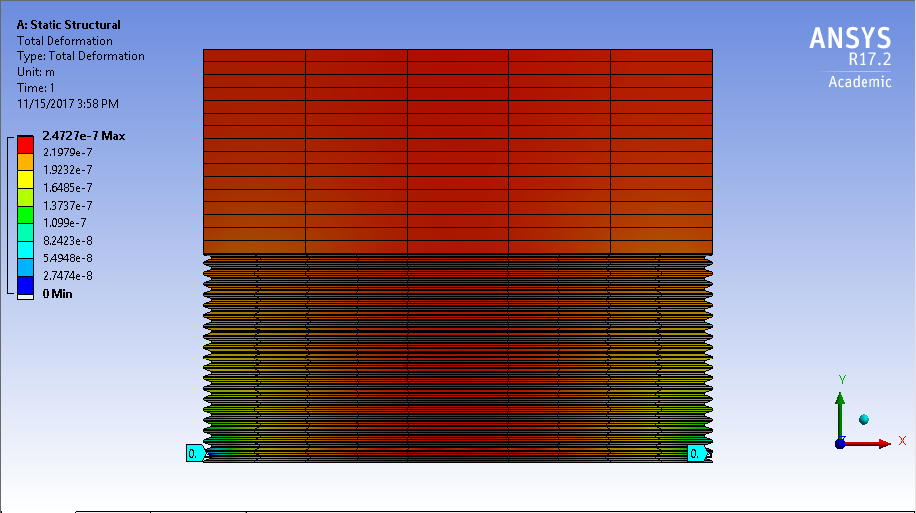

Figure 4: True-scaled deformation ANSYS result.

The true-scale model that was shown is what the model would actually look like as a result. From the figure, it is seen that the model will not deform at all to the naked eye. This does not mean that it does not deform, though. On the left side of the image, a range of deformations is shown from minimum to maximum (minimum being blue and maximum being red). That explains the colors on the model. Because the red in the model is all throughout the top and the bottom middle section, that means that those spots will have the most deformation. This makes sense because with fixed supports on the sides, the model is expected to sink in the middle, like shown in Figure 3 previously. However, when you look at the maximum deformation in meters, it is 2.5E-7. That is about 9.8E-6 inches, meaning that the deformation is on such a small scale that the model will not experience any real, dangerous deformation. The tooth on the door will not break due to the weight.

The deformation minimum was 0 meters and there are two probe results shown in Figure 4 above at the bottom on the sides. It is also shown more closely on one side in Figure 5 below.

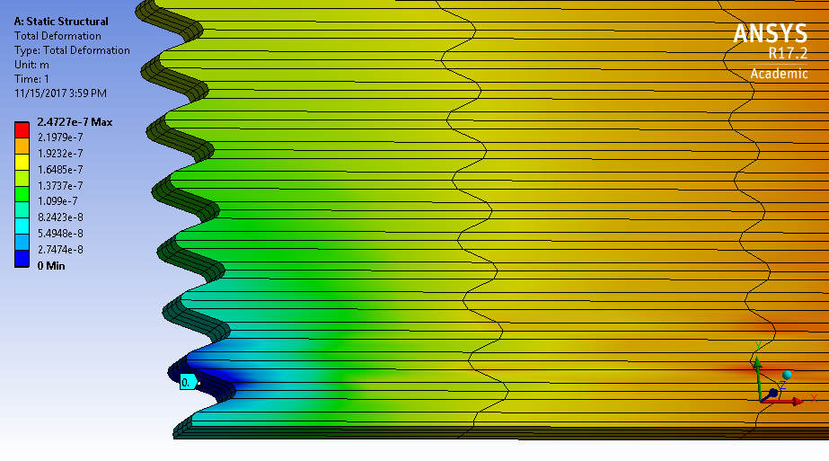

Figure 5: Close up of deformation result on tooth with fixed support.

The dark blue color is the deformation minimum of 0 meters and this is an important close-up to show because this means that our boundary condition matched up with the results. Since the tooth had a fixed support on the bottom face of it, its deformation should have been zero and that is what we see in the results, with the probe. It is very important to make sure that boundary conditions are satisfied because if they were not satisfied, then the results would probably be inaccurate, especially since this was an essential boundary condition and had to be met. The gravity boundary condition was satisfied because the model is sinking in the middle, which shows that there is a force downward due to gravity.

*Normal Stress:*

The second analysis done on the model in ANSYS was normal stress. The result is shown in Figure 6 below.

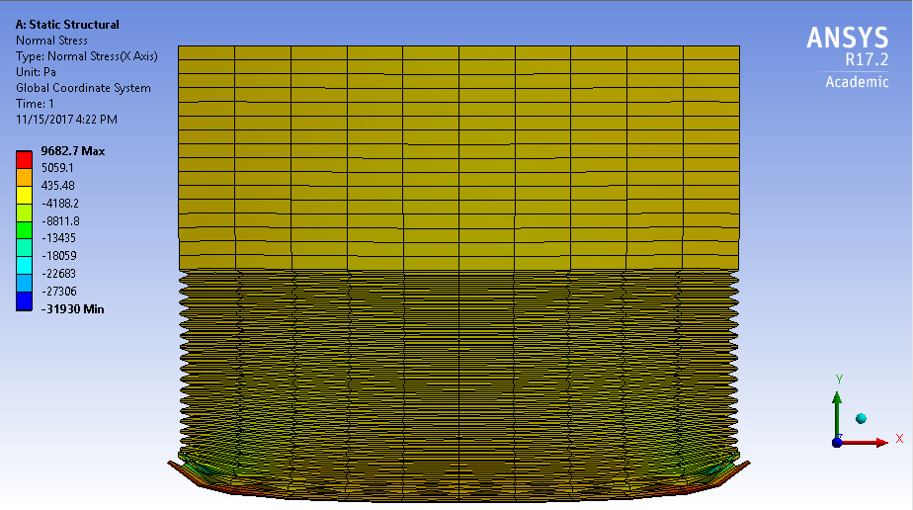

Figure 6: Auto-scaled normal stress ANSYS result.

Again, the model shown in Figure 6 is auto-scaled, which means that it is not likely to look like this. So, the true-scale model was shown (Figure 6 below).

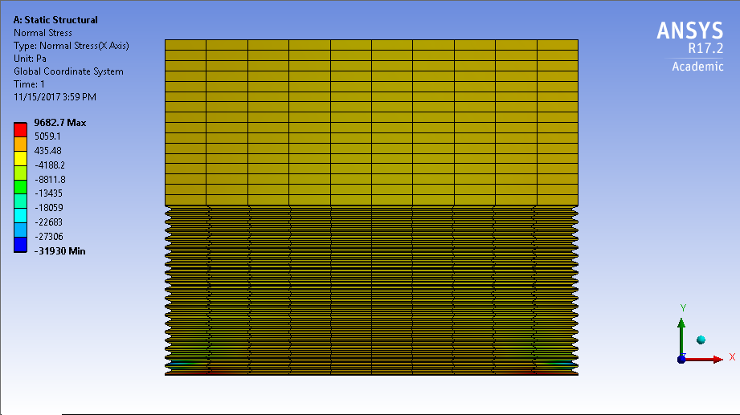

Figure 7: True-scaled normal stress ANSYS result.

From the true-scale model, it is shown that most of the model is under mild stress (the yellow color). However, once you zoom in, you see all colors, or all stresses, in both corners where the fixed supports are. Figure 8 below shows a close-up of that.

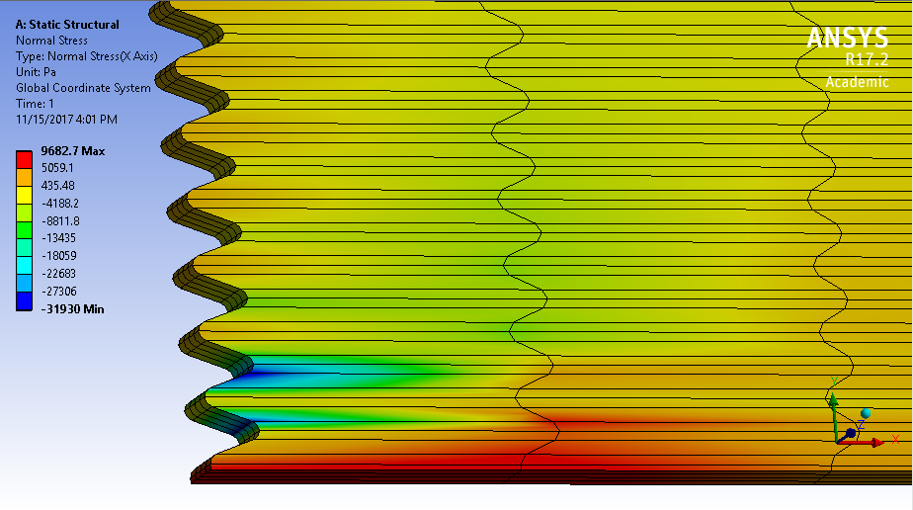

Figure 8: Close up of normal stress result on tooth with fixed support.

From the minimum of -31930 Pascals to the maximum of 9682.7 Pascals, the range is shown in the figure above. There is a dark blue concentration on the top of the tooth where the fixed support is at and that means it is about -31930 Pascals there. This means that there is a lot of compressive stress there. This makes sense because when that tooth stays fixed and the middle of the door sags down, the tooth will get close and closer to the tooth above it. In other words, it will compress. However, we also see a small amount of compression at the bottom of the tooth, which was not expected, but after looking at the auto-scale exaggerated model in Figure 9 below, it can be seen that the tooth below the fixed tooth will also get closer to the fixed tooth due to the sagging of the middle. Then, at the bottom surface of the door, the dark red color shows up and that means there is about 9682 Pascals of stress there. This stress is tensile and that makes sense because when the middle sags down, the part in red shown in Figure 8, will stretch, making it a tensile stress. The compressive and tensile stress near the fixed tooth is more explicitly shown in Figure 9 below from the auto-scale close-up.

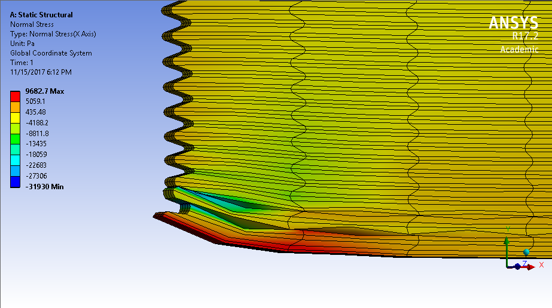

Figure 9: Close-up of auto-scaled normal stress result on fixed tooth.

**Summary**

Some points to take away from this are the satisfied boundary conditions, the results of the normal stress and total deformation, and the overall information that was gathered based on the data from ANSYS. First, to reiterate, both the gravity and fixed support boundary conditions were satisfied. The weight due to the gravity was seen in the sagging of the door in the middle and the fixed supports had a 0 meter deformation, which were expected. That was the verification because sanity checks were done. Second, the results of the deformation showed that there would be a maximum deformation in the middle of about 2E-7 meters, which is very minimal and it will not dramatically affect the door in real life. The material will not break under these circumstances. As for the normal stress, there is compressive stress on the two ends of the tooth and tensile stress on the bottom edges. However, the stress is not great enough to cause deformation. With all this in mind, it is safe to say that the teeth on the rack gear of the door will not be deformed in any due to the weight of the door if oak wood is the material used.

**Works Cited**

[1] Engineering ToolBox. “Modulus of Elasticity or Young's Modulus - and Tensile Modulus for Common Materials.” *The Engineering ToolBox*, The Engineering ToolBox , from <www.engineeringtoolbox.com/young-modulus-d_417.html>.

[2] MatWeb. “American White Oak Wood.” *MatWeb*, Material Property Data, from <www.matweb.com/search/datasheet.aspx?matguid=44cdf6b01d004baaa7e9510575891dc3&ckck=1>.

[3] Engineering ToolBox. “Densities of Wood Species.” *The Engineering ToolBox*, The Engineering ToolBox , from <www.engineeringtoolbox.com/wood-density-d_40.html>.